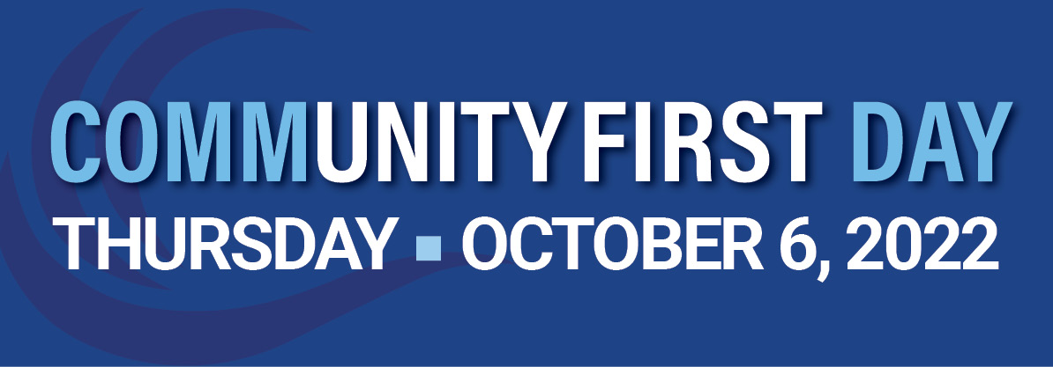

OceanFirst is proud to introduce its inaugural CommunityFirst Day! Our team is excited to partner with nonprofits across our footprint for an afternoon of service (1-5pm) and learning about the important work you do!
To be a part of this special day and host an OFB WaveMaker team, please complete the application below. Each project request will be carefully evaluated to determine feasibility; requests are not guaranteed for selection. Applicants selected to host a volunteer team will be invited to apply for a CommunityFirst Day Grant of up to $250 to help offset project supplies/expenses.
Applications are due to Julie (jbellezza@oceanfirstfdn.org) no later than August 22, 2022.
Name of Nonprofit:
Project Site Location(s) (Note Navigation Address for each Project:
Primary Contact (Name/Phone/Email):
Day of Project Leader AND Emergency Contact (Name/Cell Phone Number Preferred/Email):
# of Volunteers Requested for Each Project:
Project Details (Describe the Activities to be Completed by the WaveMakers:
Inclement Weather Plan if your Project is Outside:
Limitations/Restrictions (skills, physical, COVID protocols, etc):
Additional Information (waivers, security etc.):

